Create a basic webpage using only HTML tags below is the code of my webpage for coding platforms.

## Steps Followed to make this webpage:

Open your HTML file in a text editor.

Start with the <!DOCTYPE html> declaration to specify the HTML version.

Use the <html>, <head>, and <body> tags to structure your document.

Add at least one heading (<h1> or <h2>), paragraph (<p>), and list (<ul> or <ol>) to your webpage.

Include additional content, such as images (<img>), links (<a>), and basic formatting tags (<strong>, <em>, <br>).

Use semantic HTML elements like <header>, <main>, and <footer> to describe the purpose of different sections of your webpage.

Include at least one ordered or unordered list (<ul> or <ol>) and one table (<table>) in your webpage.

Save your changes and open your HTML file in a web browser to see the updates.

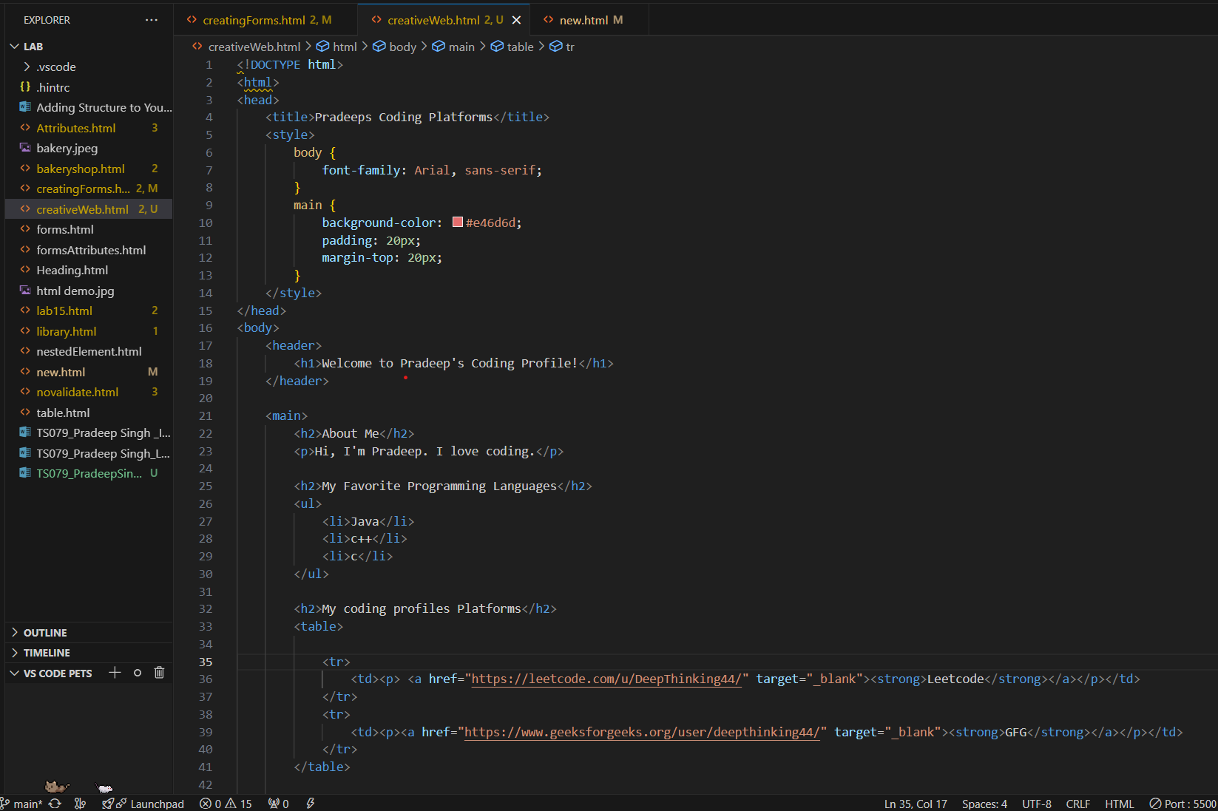

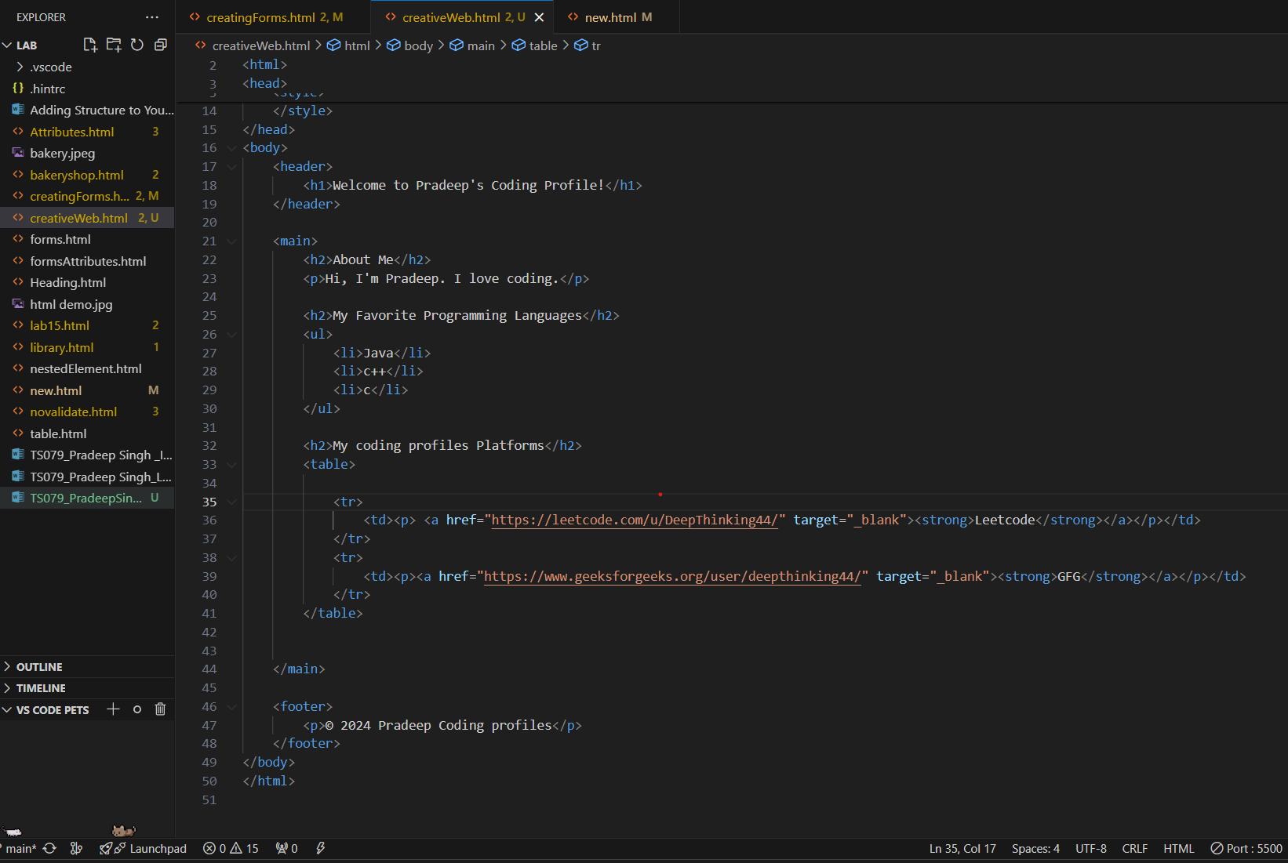

Output will look like as below:

